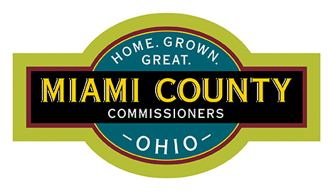
FACILITIES AND MAINTENANCE DEPARTMENT

Ben Howlett, Director
209 W. Water Street
Troy, Ohio 45373

Office: 937-440-5999
Fax: 937-440-3541
Email: bhowlett@miamicountyohio.gov

Board of Miami County Commissioners
201 W Main Street
Troy, Ohio 45373

RESPONSE: RFI 02-Second Round Interviews
Issued 10/11/2024

PROJECT:
Miami County: Job and Family Services Statement of Qualifications
2040 North County Road 25A, Troy, OH 45373

TO ALL SECOND ROUND INTERVIEWEES:

QUESTION:
A firm asked the following question:
Can you provide current staffing numbers broken out by division?

RESPONSE:
Current Staff Numbers by Division:

Miami County JFS
1 Director

Public Assistance/ Workforce
1 Administrator
3 Supervisors
8 Staff (Workforce)
21 Staff (Public Assistance)

Child Support
1 Administrator
2 Supervisors
20 Staff

Child Protective Services
1 Administrator
4 Supervisors
26 Staff

Business Office
1 Administrator
3 Supervisors
19 Staff

QUESTION:
A firm asked the following question:
Will existing drawings be provided to the selected firm?

RESPONSE:
Yes. The County only currently has hardcopies of drawings for the facility, but they will be provided to the selected firm. We strongly recommend that site verification be preformed by the selected firm to confirm all existing conditions at the facility as the drawings sets may not reflect fully the existing conditions.

QUESTION:
A firm asked the following question:
Does the County require expansion of the existing footprint of the building?

RESPONSE:
The County holds no preconceived notions on what the final design might be for the building. The goal is for the selected firm to work with the County through the design process to determine what is best for the County for the next 30 years.

REMINDER:
We look forward to meeting with the final four firms on October 23rd. Please note that the interviews will be held in the large conference off of the Ohio Means Jobs space.

Current Interview Schedule:
October 23rd at 10:00 AM- Levin Porter Architects
October 23rd at 11:00 AM- LWC, Inc.
October 23rd at 1:00 PM- WDC Group
October 23rd at 2:00 PM- Kleinfelder

Revised Interview Times:
Thirty (30) Minutes for the Firms to present
- Committee may ask questions about the items being presented
Fifteen (15) minutes for Committee Questions
- Committee may ask questions about the items being presented
Ten (10) minutes for Committee Deliberation
Five (5) minutes for next firm to set up

Note: The Committee may run long in deliberation, but all firms will have their full time to present.

Equipment:
A projector and screen will be available for use, but recommend your own equipment to present.

RFIs:
We ask to have any final requests for information from firms by 4pm Friday, October 18th. Final responses will be answers by 12 noon Monday, October 21st.

RFIs can be submitted via email to Ben Howlett at bhowlett@miamicountyohio.gov or by phone at 937-440-5999

End of RFI Response

