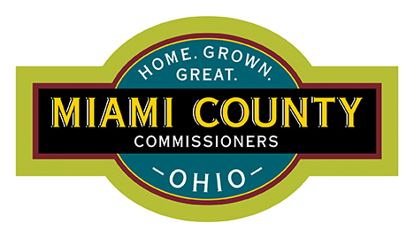
FACILITIES AND MAINTENANCE DEPARTMENT

Ben Howlett, Director
209 W. Water Street
Troy, Ohio 45373

Office: 937-440-5999
Fax: 937-440-3541
Email: bhowlett@miamicountyohio.gov

Board of Miami County Commissioners
201 W Main Street
Troy, Ohio 45373

RESPONSE: RFI 01-Second Round Interviews
Issued 10/2/2024

PROJECT:
Miami County: Job and Family Services State of Qualifications
2040 North County Road 25A, Troy, OH 45373

TO ALL SECOND ROUND INTERVIEWEES:

A firm asked the following question:
Are there any specific priorities or topics we should address in our 30-minute time allotment?

If you wish to tour the building before the interviews on October 23rd, 2024 please send me an email at bhowlett@miamicountyohio.gov or call at 937-440-5999 to set up a tour.

RESPONSE:

Below is a list of five (5) major areas that should be covered during the interview process. Of the five major items, an important item to the Committee is the Project Understanding and End User Engagement.

- Team Collaboration:
  - Introduce the team members who would be involved, focusing on their expertise and roles.
    - What sets your firm apart from the other firms being interviewed?
  - Highlight any previous work with government entities and coordination with multiple stakeholders.

- Project Understanding and End User Engagement:
  - Clearly articulate your understanding of the renovation and expansion project.
    - This includes but not limited to:
      - How to keep the building operational during construction
      - What limitations for expansion may be on the site
      - What are the goals from the stakeholders to create a successful building?
  - Outline the key goals, such as improving service delivery, creating an efficient workspace, and addressing any specific user or client needs.
  - Many of the currently Committee Members have never gone through the architectural design process
    - Explain your processes for designing a space
      - How do you engage with the stakeholders for a successful outcome?
      - How is feedback gathered from the end users?
        - Are there pre-design stakeholder meetings?
          - How are stakeholder meetings run in the pre-design?
        - Are there surveys?
      - Are block planning and renderings used to show the perspective new areas?
      - Explain why certain design items are required (ADA, Fire and Life Safety egress, etc.) and how they can be enhanced through architectural design

- Experience and Qualifications:
  - Highlight relevant experience with similar projects, particularly in renovating public service buildings.
    - After the work was complete, what worked out well for the end user?
    - After the work was complete, what didn’t work out well?
      - What has your firm learned to make the next project better.
  - Emphasize your firm’s qualifications in meeting government and community standards, especially regarding accessibility, energy efficiency, and long-term usability.

- Project Approach:
  - Describe your approach to project management, including timelines, communication, and collaboration with stakeholders.
  - Address how you will ensure minimal disruption to ongoing services during the renovation.

- Budget and Value Management:
  - Discuss strategies for staying within budget while ensuring high-quality outcomes.
  - Focus on cost-effective solutions without sacrificing critical components of the renovation.
By addressing these priorities, you can maximize the effectiveness of the 30-minute interview and demonstrate a clear understanding of the project's scope and the County’s needs.

End of RFI Response

